Iteration 5

Swiftriver

**Class Diagram** **3**

**Database design and data definitions** **4**

Camper Record 6

Summer Camp Event 9

Volunteer Record 11

Picture Record 13

Board of Directors Record 14

Board of Directors Record 15

Item Sale Record 16

Grant Record 17

Item Record 18

Events 19

Fundraising 20

Horse Data 21

**User Interface Navigation Diagram and Screen Layouts** **22**

**Gantt Chart** **23**

**Use Interface Prototype** **24**

Add/Modify Camper Record 24

Delete Camper Record 25

Add/Modify Summer Camp Event 26

Delete Summer Camp Event 27

View Summer Camp Event 28

# Class Diagram

The diagram shows how each user and action interacts with each other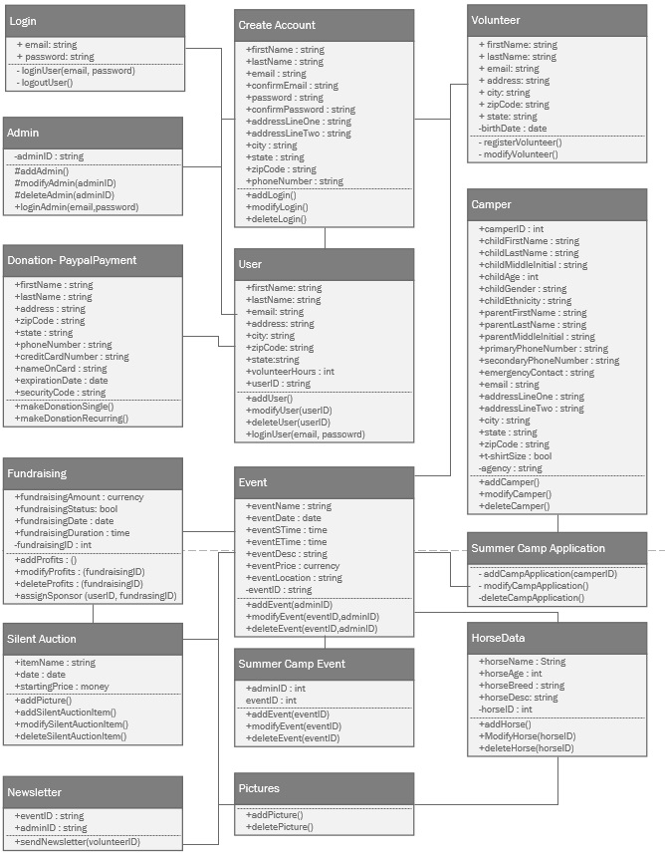

# Database design and data definitions

ERD graphically indicates information of the relationships between the system entities.

**ERD:**

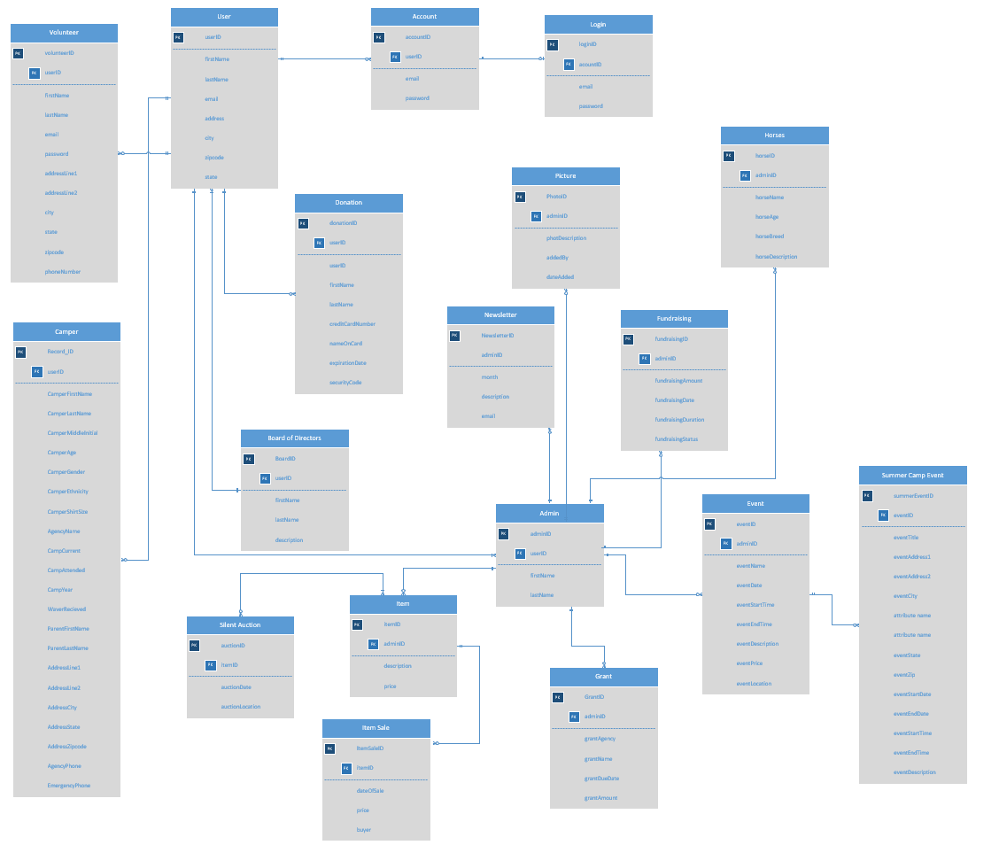

How to read data dictionary tables

A data dictionary table is a set of information that describes database entities and their relationships to each other. There are 6 columns on each table.The entity name is the name of the entity, followed by a short description of that entity. Next is the attribute name and the attribute definition. Attributes are values of an entity. The data type and size of the data are the lat two columns of the table. The purpose of the data dictionary is to make sure the database designer has enough information to make the database tables and fields.

## 

## 

## 

## 

## 

## 

## 

## 

## 

## 

## Camper Record

|  |  |  |  |  |  |
| --- | --- | --- | --- | --- | --- |
| Entity Name | Entity Description | Attribute Name | Attribute Definition | Date Type | Size |
| Camper Record | A record of a camper’s information. | Record_ID  (PK) | Unique identifier for camper record | Char | 10 |
|  |  | camperFirstName | First name of camper | String | 25 |
|  |  | camperLastName | Last name of camper | String | 25 |
|  |  | camperMiddleInitial | Middle Initial of camper | String | 1 |
|  |  | camperAge | Age of camper | Char | 2 |
|  |  | camperGender | Gender of camper | String | 1 |
|  |  | camperEthinicity | Ethnicity of camper | String | 15 |
|  |  | camperShirtSize | T-shirt size of camper | String | 5 |
|  |  | agencyName | Name of agency camper is from | String | 25 |
|  |  | campCurrent | Current summer camp the camper is attending | String | 25 |
|  |  | campAttended | Past summer camps the camper has attended | String | 25 |
|  |  | campYear | Year of the current summer camp the camper is attending | Char | 4 |
|  |  | waverRecieved | Validates if camper’s waiver is received | Bool | 2 |
|  |  | parentFirstName | First name of parent | String | 25 |
|  |  | parentLastName | Last name of parent | String | 25 |
|  |  | addressLine1 | First address line of parent’s address | String | 25 |
|  |  | addressLine2 | Second address line of parent’s address | String | 25 |
|  |  | addressCity | City of parent’s address | String | 25 |
|  |  | addressState | State of parent’s address | String | 25 |
|  |  | addressZipcode | Zip code of parent’s address | Char | 10 |
|  |  | agencyPhone | Phone number of agency | Char | 10 |
|  |  | emergencyPhone | Emergency contact phone numbers | Char | 10 |
|  |  |  |  |  | TOTAL SIZE  345 |

## 

## 

## 

## Summer Camp Event

## 

|  |  |  |  |  |  |
| --- | --- | --- | --- | --- | --- |
| Entity Name | Entity Description | Atribute Name | Attribute Definition | Data Type | Size |
| Summer Camp Event | An event that takes place in summer camp | summerEventID  (PK) | Unique identifier for event | Char | 10 |
|  |  | eventTitle | Title of the event | String | 25 |
|  |  | eventAddress1 | Address line 1 of the event | String | 25 |
|  |  | eventAddress2 | Address line 2 of the event | String | 25 |
|  |  | eventCity | City of the event | String | 25 |
|  |  | eventState | State of the event | String | 2 |
|  |  | eventZip | Zip code of the event | Char | 10 |
|  |  | eventStartDate | Start date of the event | Char | 10 |
|  |  | eventEndDate | End date of the event | Char | 10 |
|  |  | eventStartTime | Start time of the event | Char | 5 |
|  |  | eventEndTime | End time of the event | Char | 5 |
|  |  | eventDescription | Description of the event | String | 100 |
|  |  |  |  |  | TOTAL SIZE  252 |

## 

## Volunteer Record

|  |  |  |  |  |  |
| --- | --- | --- | --- | --- | --- |
| **Entity Name** | **Entity Description** | **Attribute Name** | **Attribute Defintion** | **Date Type** | **Size** |
| Volunteer | A record of a volunteer’s information. | volunteerID (PK) | Unique Identification number | Integer | 10 |
|  |  | firstName | First name of volunteer | String | 25 |
|  |  | lastName | Last name of volunteer | String | 25 |
|  |  | email | Email of Volunteer (Login username) | String | 25 |
|  |  | password | Password for account login | String | 15 |
|  |  | addressLine1 | Address of volunteer | String | 25 |
|  |  | addressLine2 | Address of volunteer | String | 25 |
|  |  | city | City of volunteer | String | 25 |
|  |  | state | State of volunteer | String | 2 |
|  |  | Zipcode | Zip code of volunteer | String | 9 |
|  |  | phoneNumber | Phone number of volunteer | String | 10 |
|  |  |  |  | Total Size | 196 |

## Picture Record

|  |  |  |  |  |  |
| --- | --- | --- | --- | --- | --- |
| **Entity Name** | **Entity Description** | **Attribute Name** | **Attribute Defintion** | **Date Type** | **Size** |
| Photo | Photo uploaded to website | **Photo_ID** (PK) | Unique identifier for photo | int | 10 |
|  |  | Photo_Desc | Description of what the photo is about | string | 500 |
|  |  | Added_By | Who uploaded the photo | string | 20 |
|  |  | Date_Added | When the photo was uploaded | string | 10 |

## Board of Directors Record

|  |  |  |  |  |  |
| --- | --- | --- | --- | --- | --- |
| **Entity Name** | **Entity Description** | **Attribute Name** | **Attribute Defintion** | **Date Type** | **Size** |
| Board of directors | Board member profile | **Board_ID** (PK) | Unique identifier for Board Members | int | 10 |
|  |  | First name | First name of board member | string | 20 |
|  |  | Last name | Last name of board member | string | 20 |
|  |  | description | Description of board member | string | 500 |

## Board of Directors Record

|  |  |  |  |  |  |
| --- | --- | --- | --- | --- | --- |
| **Entity Name** | **Entity Description** | **Attribute Name** | **Attribute Defintion** | **Date Type** | **Size** |
| Newsletter | Page featuring newsletters | **Newsletter_ID** (PK) | Unique identifier for newsletter | int | 10 |
|  |  | Month | Month of newsletter | string | 10 |
|  |  | Description | Description of newsletter with link | string | 50 |
|  |  | Email | Email used to sign up for newsletter | string | 50 |

## Item Sale Record

|  |  |  |  |  |  |
| --- | --- | --- | --- | --- | --- |
| **Entity Name** | **Field Name** | **Data Type** | **Field Length** | **Constraint** | **Description** |
| Item | Item_ID | Int | 10 | Primary Key | Item_ID, auto generated. |
|  | Date_Of_Sale | Date | 10 | Not Null | Date item was sold. |
|  | Price | Decimal | (19,4) | Not Null | The price the item sold for. |
|  | Buyer | Varchar | 20 | Not Null | The name of the buyer |

## 

## 

## 

## 

## 

## 

## Grant Record

|  |  |  |  |  |  |
| --- | --- | --- | --- | --- | --- |
| **Entity Name** | **Field Name** | **Data Type** | **Field Length** | **Constraint** | **Description** |
| Grant | Grant_ID | Int | 10 | Primary Key | Grant_ID, auto generated. |
|  | Grant_Agency | Varchar | 20 | Not Null | The name of the grant agency. |
|  | Grant_Name | Varchar | 20 | Not Null | The Name of the grant. |
|  | Grant_Due_Date | Date | 10 | Not Null | Date grant is due. |
|  | Grant_Amount | Decimal | (19,4) | Not Null | The price the item sold for. |

## Item Record

|  |  |  |  |  |  |
| --- | --- | --- | --- | --- | --- |
| **Entity Name** | **Field Name** | **Data Type** | **Field Length** | **Constraint** | **Description** |
| Item_Sale | Item_ID | Int | 10 | Primary Key | Item_ID, auto generated. |
|  | Description | Varchar | 200 | Not Null | A description of the item. |
|  | Price | Decimal | (19,4) | Not Null | The price the item sold for. |

## 

## Events

|  |  |  |  |  |  |
| --- | --- | --- | --- | --- | --- |
| **Entity**  **Name** | **Entity Description** | **Column**  **Name** | **Column Description** | **Data**  **Type** | **Size(Byte)** |
| **Event** | An event which HOOF hosts for donations or fundraising | eventID | Unique identification number | integer | 2 |
|  |  | eventName | Name of the event | string | 50 |
|  |  | eventDate | Date of the event | date | 3 |
|  |  | eventStime | Start time of the event | time | 3 |
|  |  | eventEtime | End time of the event | time | 3 |
|  |  | eventDescription | Description of the event | string | 500 |
|  |  | eventPrice | Price for participation for the event | string | 4 |
|  |  | eventLocation | Location of the event | string | 100 |
|  |  |  |  |  | **Total Bytes**  **665** |

## Fundraising

|  |  |  |  |  |  |
| --- | --- | --- | --- | --- | --- |
| **Entity**  **Name** | **Entity Description** | **Column**  **Name** | **Column Description** | **Data**  **Type** | **Size(Byte)** |
| **Fundraising** | An action by an admin to record funds | fundraisingID | Unique identification number | integer | **2** |
|  |  | fundraisingAmount | Amount of funds gained from event | integer | **10** |
|  |  | fundraisingDate | Date of the fundraising | date | **3** |
|  |  | fundraisingDuration | Length of time of the fundraising | time | **3** |
|  |  | fundraisingStatus | Is the event still going on | bool | **>1** |
|  |  |  |  |  | **Total Bits**  **19** |

## 

## 

## 

## 

## Horse Data

|  |  |  |  |  |  |
| --- | --- | --- | --- | --- | --- |
| **Entity**  **Name** | **Entity Description** | **Column**  **Name** | **Column Description** | **Data**  **Type** | **Size(Bits)** |
| **HorseData** | Records HOOF’s horse information | horseID | Unique identification number | integer | 2 |
|  |  | horseName | Horse’s Name | string | 25 |
|  |  | horseAge | Age of the horse | integer | 3 |
|  |  | horseBreed | Breed of the horse | string | 10 |
|  |  | horseDescription | Description of the horse | string | 500 |
|  |  |  |  |  | **Total Bits**  540 |

# 

# 

# 

# User Interface Navigation Diagram and Screen Layouts

Relational depictions for contents in the system project. The navigation diagram organizes contents to show a screen flow.

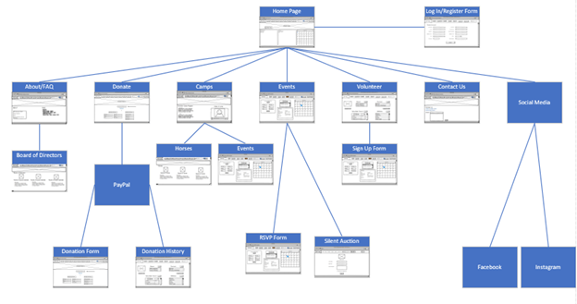

# Gantt Chart

This chart has the name of the task and the name of the group member performing the task to the left of the chart. Each task has a bar that indicated the length of the task, measured in days. Some tasks are independent and can be started whenever while others are dependent and require certain tasks be completed before they can be started. A dependent task is indicated by its starting point being at the end of another task instead of being on the first day like the other tasks. Where the bar starts indicates which task it depends on.

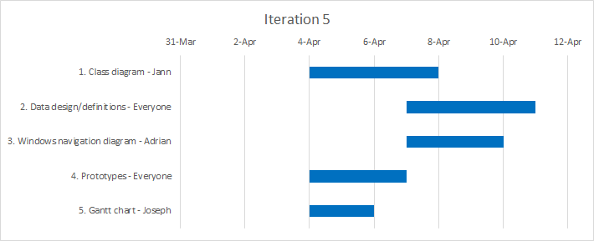

# Use Interface Prototype

Prototypes shows the layout for an indicated business process and how it would look on a website.

## Add/Modify Camper Record

# 

## Delete Camper Record

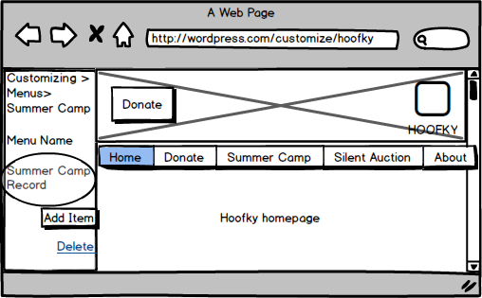

## Add/Modify Summer Camp Event

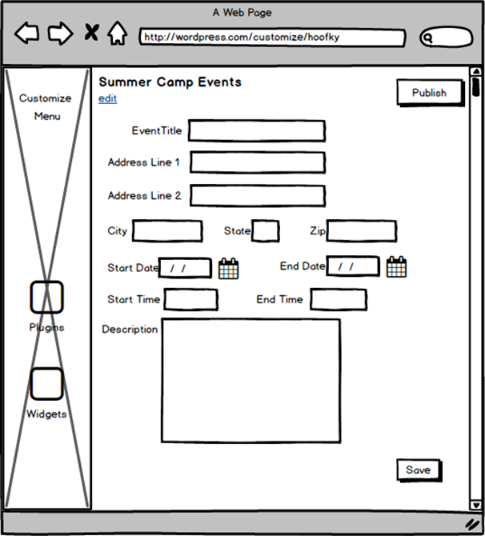

## 

## 

## 

## 

## Delete Summer Camp Event

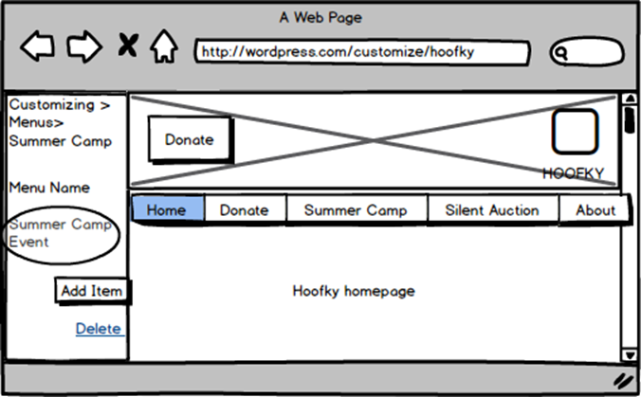

## View Summer Camp Event

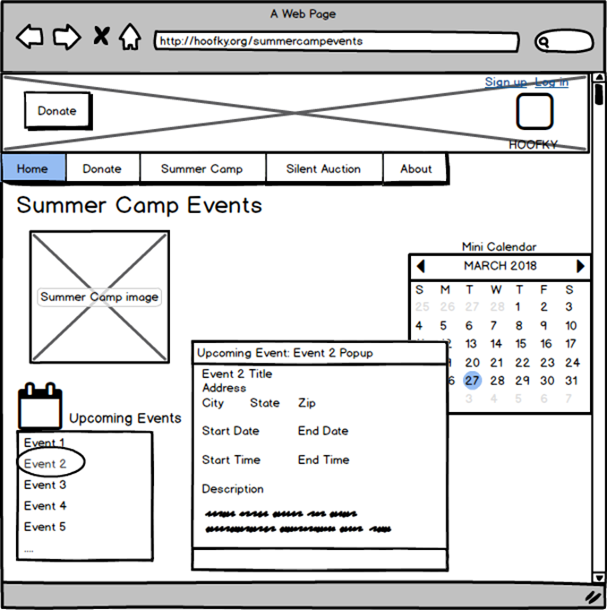

Add Volunteer Record

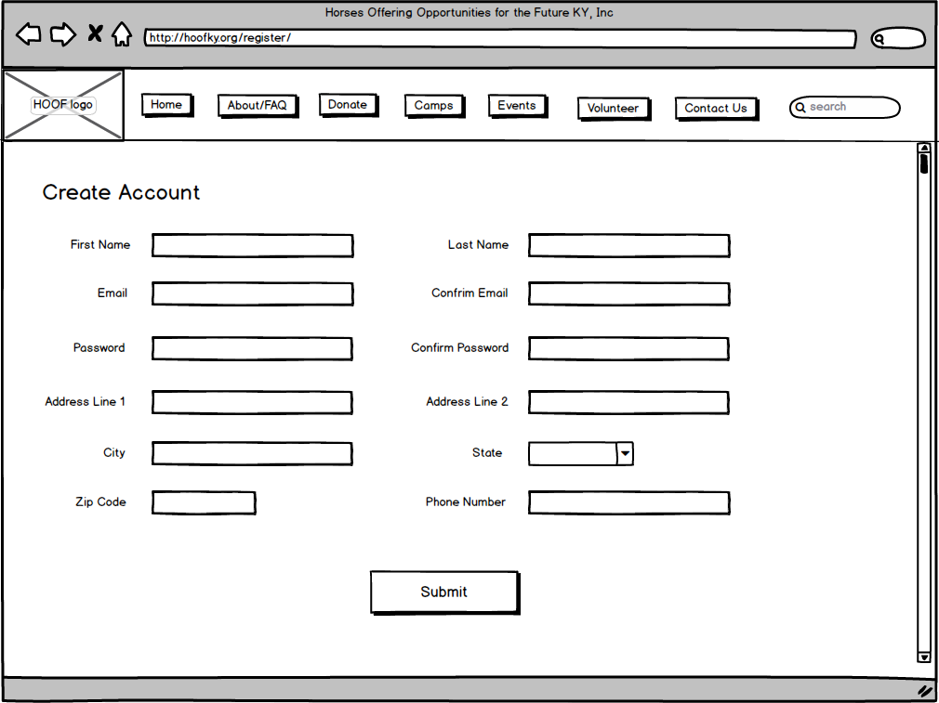

Modify Volunteer

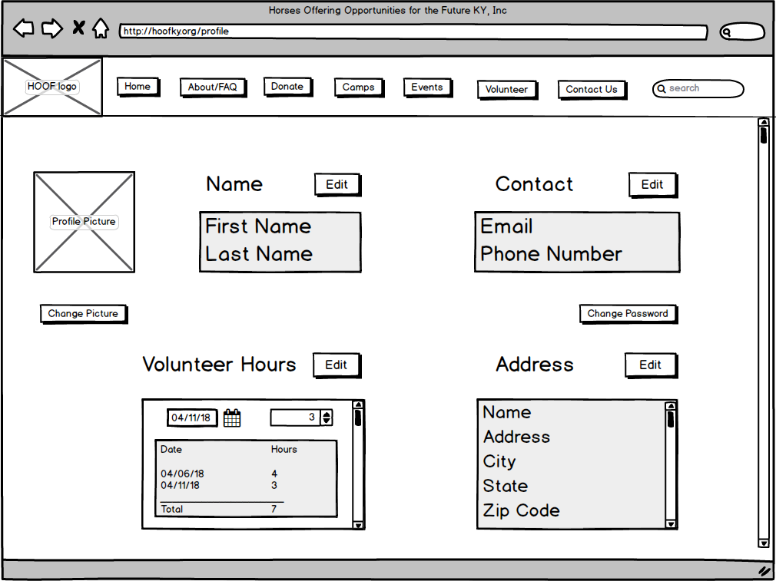

Delete Volunteer

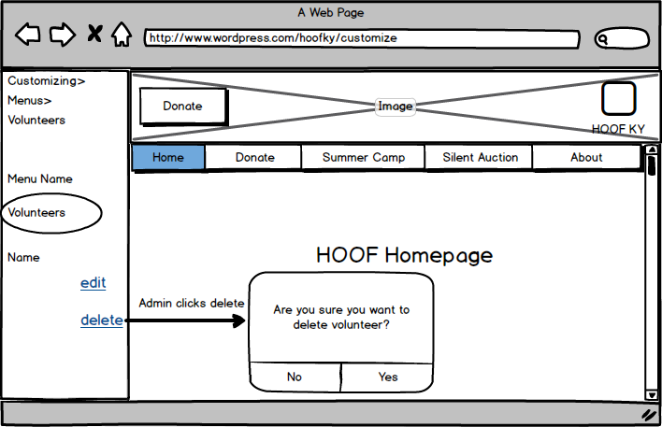

Add/Modify/ Delete Events

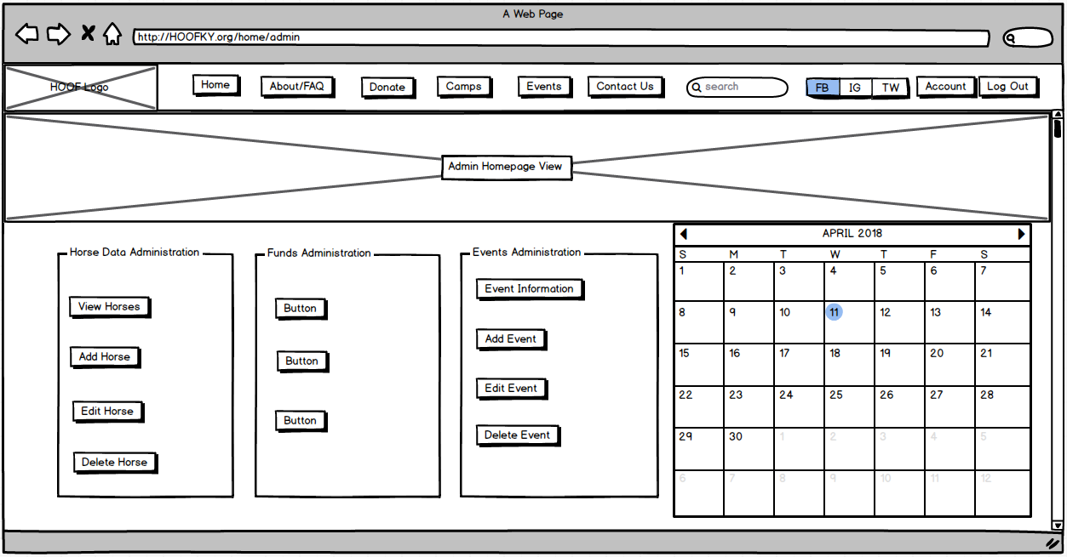

View Events

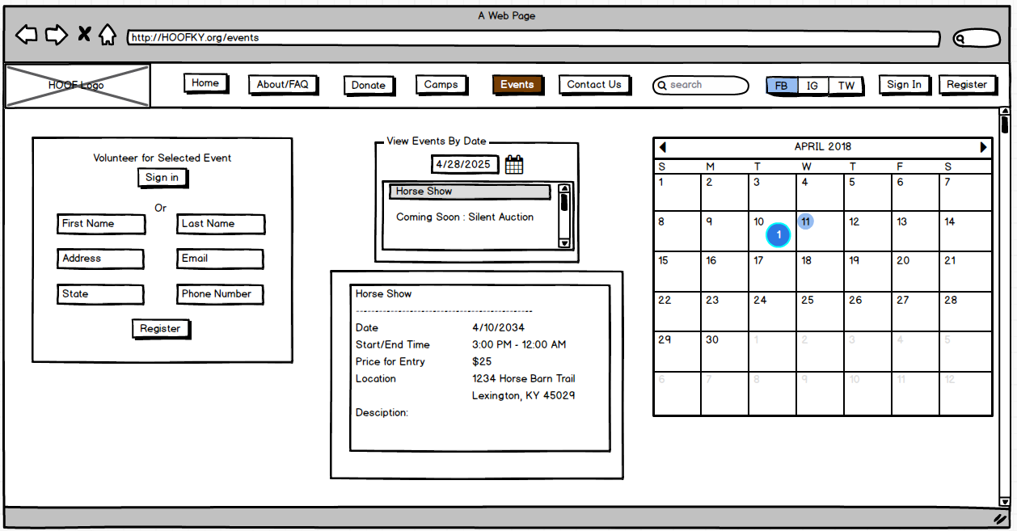

View Horse Data

